DIRECT DEPOSIT FOR LANDLORDS (ACH)

Housing Authority City of Kennewick (KHA) is pleased to offer a new Housing Authority Payment (HAP) convenience – Direct Deposit. Now HAP checks can automatically be deposited into your checking or savings account at approximately the first of the month. No changes are required to your present banking relationship to take advantage of this service.

The advantages of Direct Deposit are:
- It saves trips to the financial institution.
- It saves time in depositing checks – no long payday lines to wait in.
- It eliminates the possibility of lost, stolen, or forged checks.
- No more waiting for the Post Office to deliver!
- HAP Payment is deposited faster –No waiting for HAP checks to clear the bank– reduces the possibility of overdrafts.
- It means HAP payments are deposited to your bank account even if on vacation or away on business or illness.

Here’s how Direct Deposit works:
At around the first of the month you will receive a statement sent to your email account, showing HAP rent amount and name of tenant, the same as is now listed on the check stub. HAP will already have been deposited in to your account. We believe you will like the added convenience of having HAP payments automatically deposited to your bank account.

Direct Deposit is safe, convenient, and easy. To take advantage of this service, complete the attached authorization form and return it to:

Housing Authority City of Kennewick
Attn: Accounting Dept
1915 W 4th Place
Kennewick, WA 99336

The authorization form, which is attached, gives KHA and your financial institution authority to deposit your HAP to your bank account. Simply complete the form in and attach a voided check or deposit slip in order to take advantage of Direct Deposit.

All you need to do is:
- Mark the box before type of account to indicate whether the HAP will be deposited in your checking or saving account.
- Fill in your name, financial institution name and location, and date.
- Attach a voided check for verification of all financial information. If you are unable to attach a voided check for a savings account, contact your banking institution for the transit #, account #, bank code# and Federal Reserve code#.
- A valid email account number is required to take advantage of this option.
- Be sure to sign the form and list your email account number!

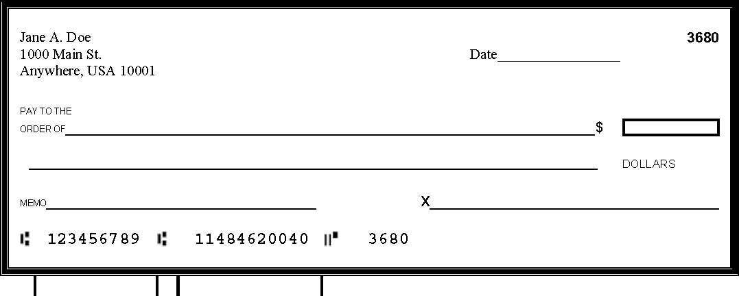
Bank Code / Fed Res Code
98-8126/3251 1

Transit No. Account No.

(A voided check is needed for this option! This is important due to bank and Federal Reserve codes listed on the slip)

DIRECT DEPOSIT
AUTHORIZATION
FORM

I agree as a condition of HAP contract, to have Kennewick Housing Authority (KHA) deposit my HAP check directly to my account at the bank/credit union listed below. I agree to notify Housing Authority City of Kennewick immediately of any changes to the information so that HAP may be properly distributed. Please attach a voided check from bank/credit union for the account.

New Agreement Change Account Cancel Agreement

Select One: Checking Savings: Bank code Fed res code

Name of Bank/Credit Union | Routing/Transit No. | Account No.

**I understand that Housing Authority City of Kennewick (KHA) may authorize my financial institution to debit my account for any deposits that are not for the correct amount due.**

Printed Name of Landlord/Apartments |  |  |  | Title |  |  |  | Phone Number
Landlord/Representative Full Signature |  | Date |  |  |  | Email Account # (**REQUIRED**)

This authority remains in full force & effect until KHA has received written notification from Landlord/Representative. Written notification must be received fifteen (15) days prior to next pay period for changes to take effect.

Original copy to: Accounting Dept/Landlord file

